# JMeter-configuration with Jenkins

Step1: created virtual box in our local with Ubuntu OS

Step2: steps to create virtual box

Installed virtual box from here: <https://www.virtualbox.org/wiki/Downloads>

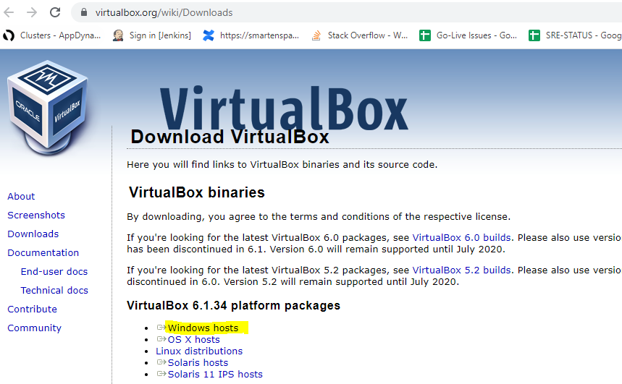

**Step3:** download Ubuntu OS from here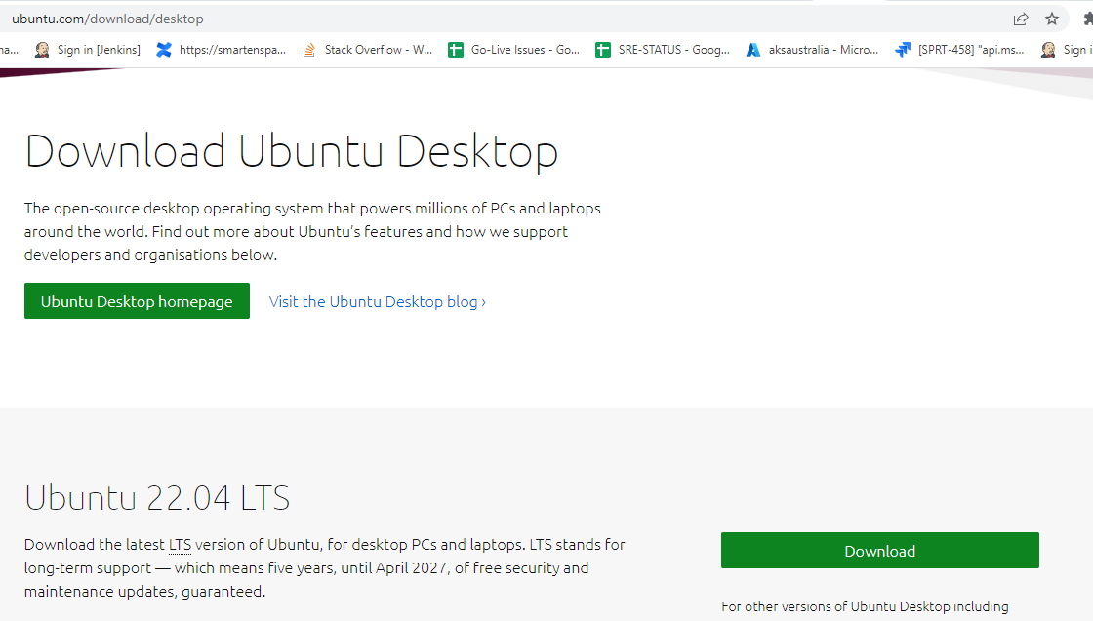

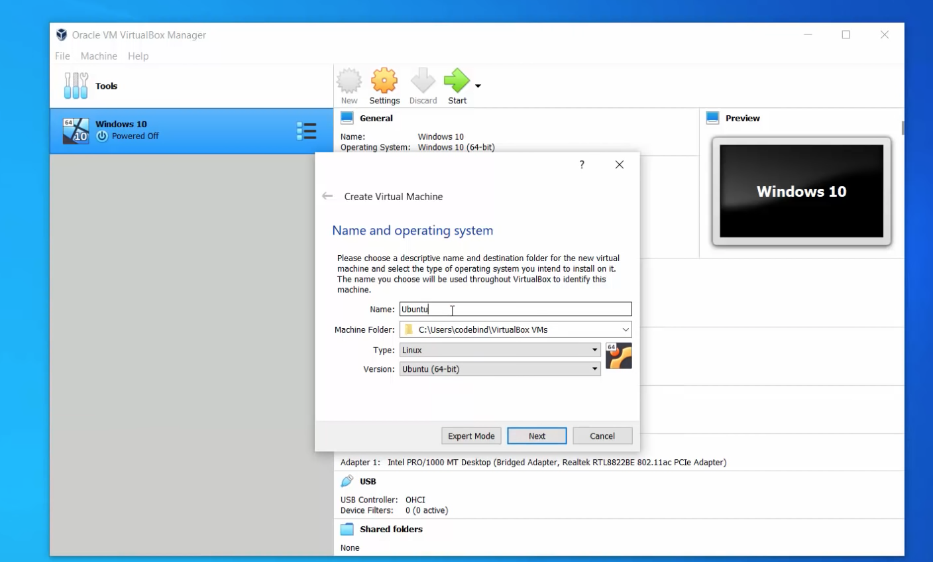

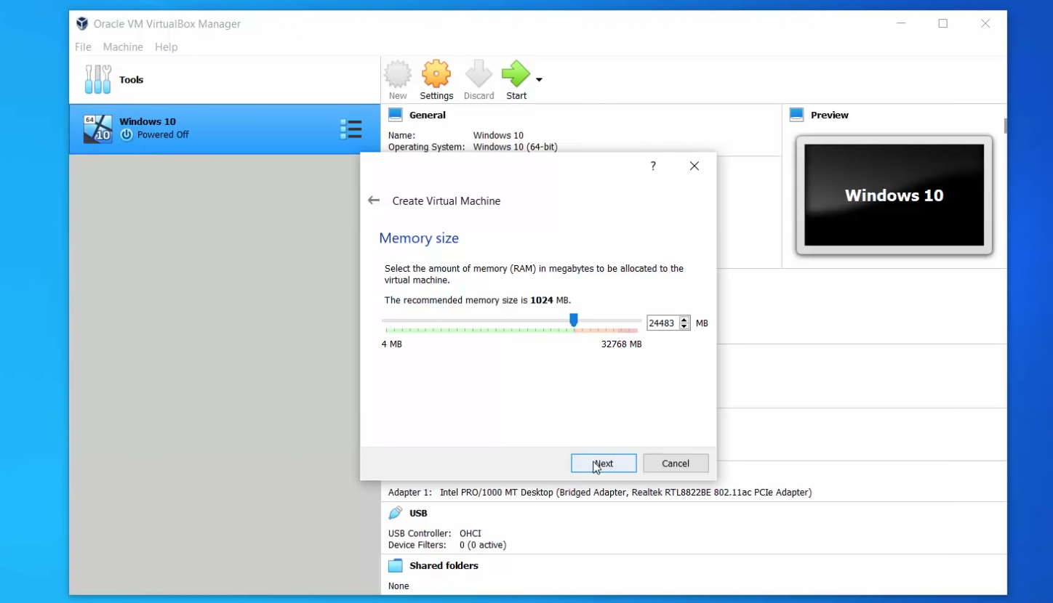

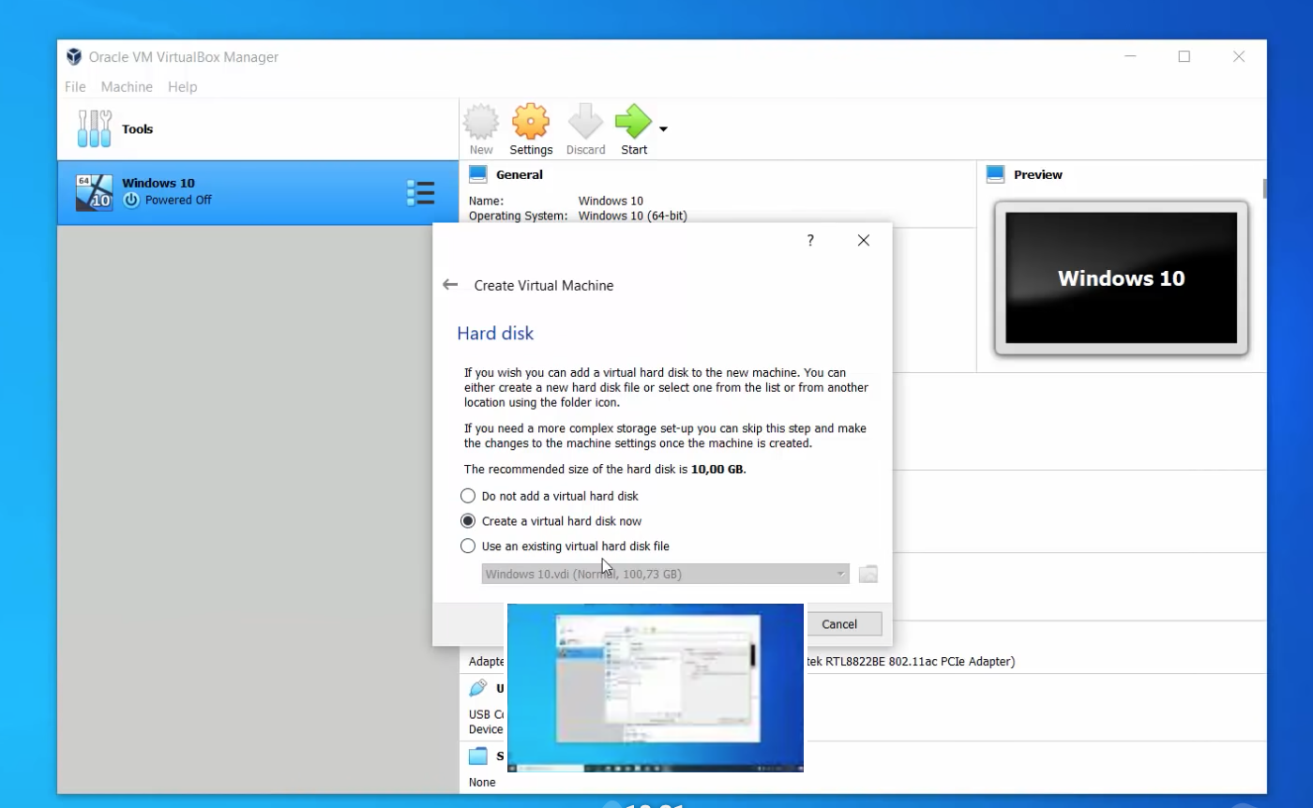

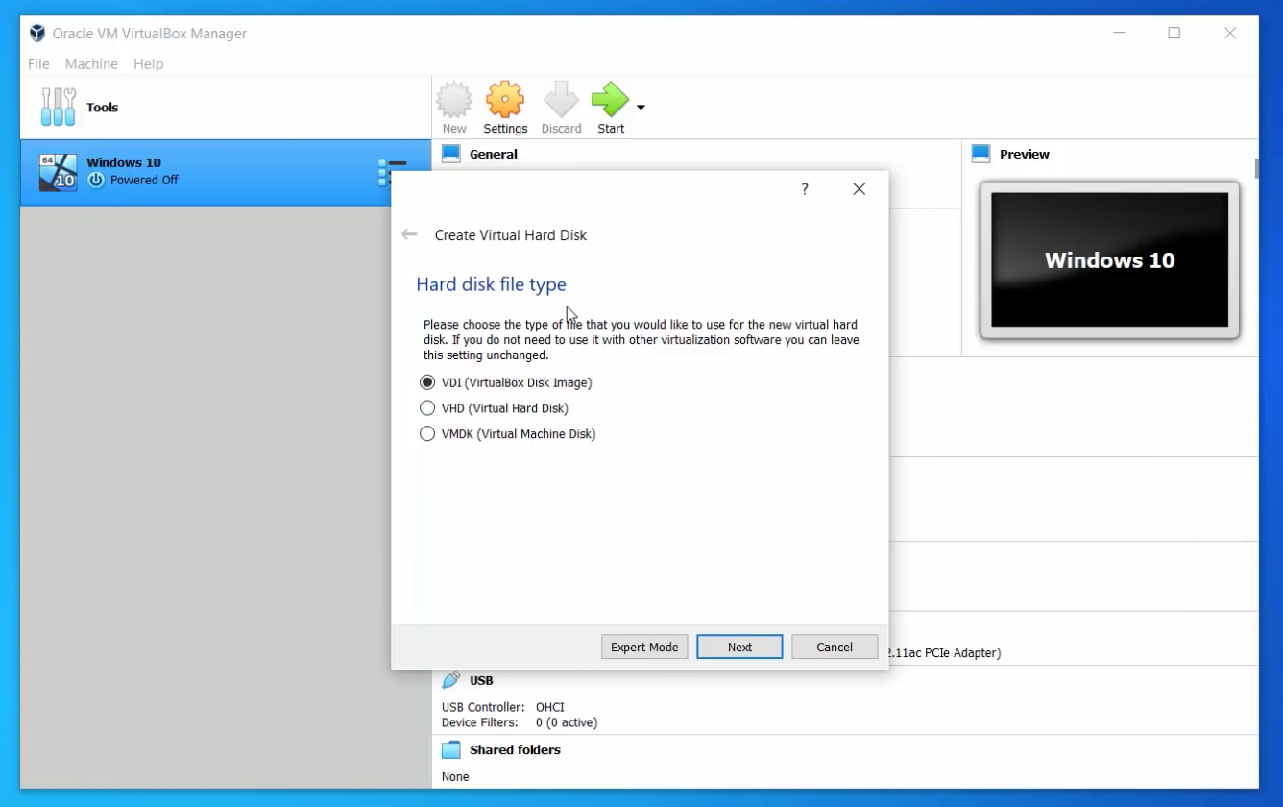

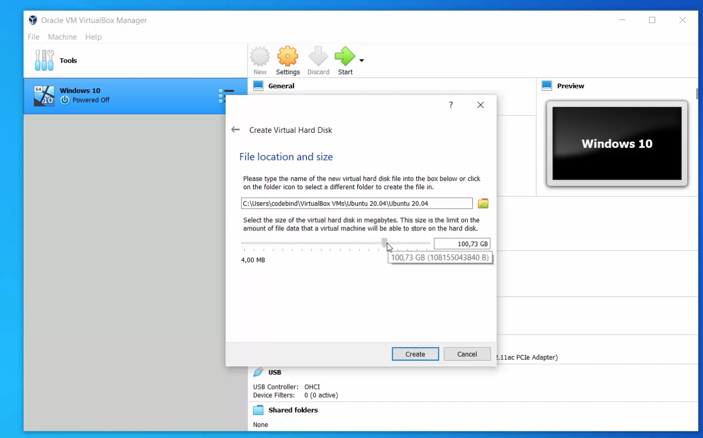

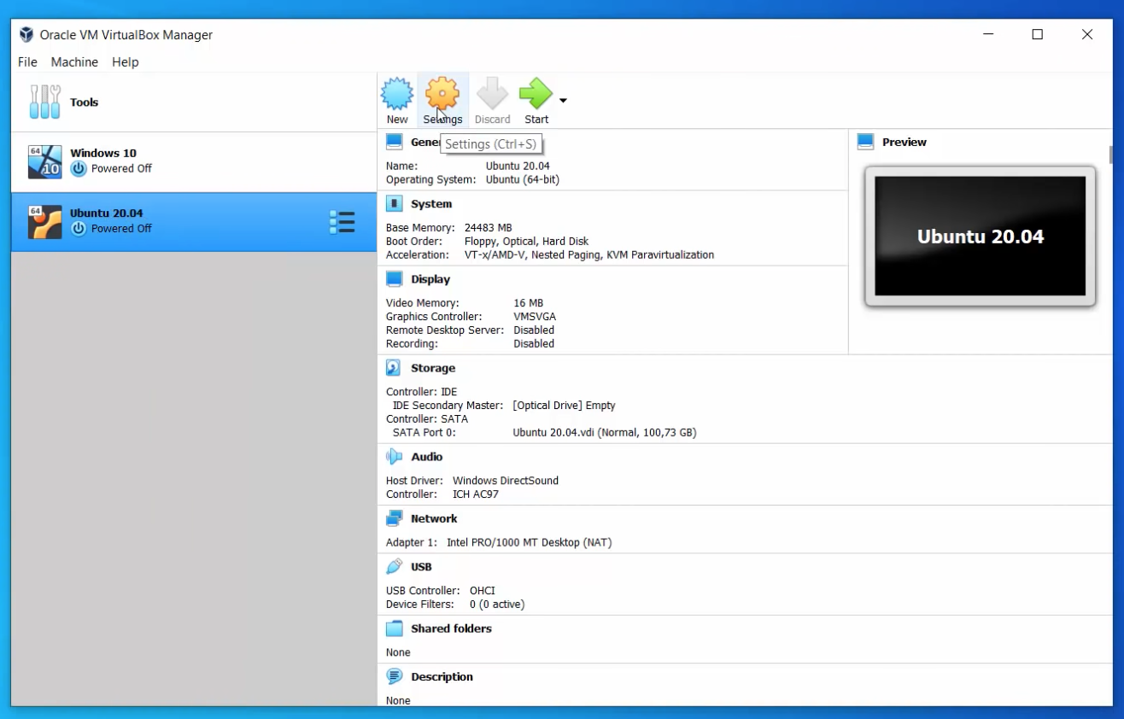

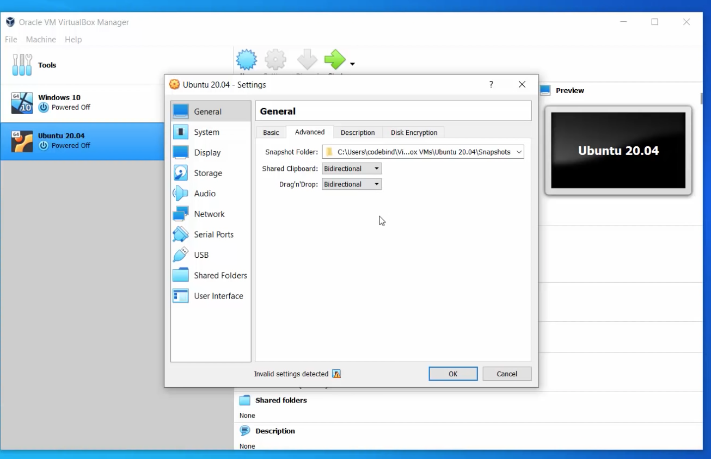

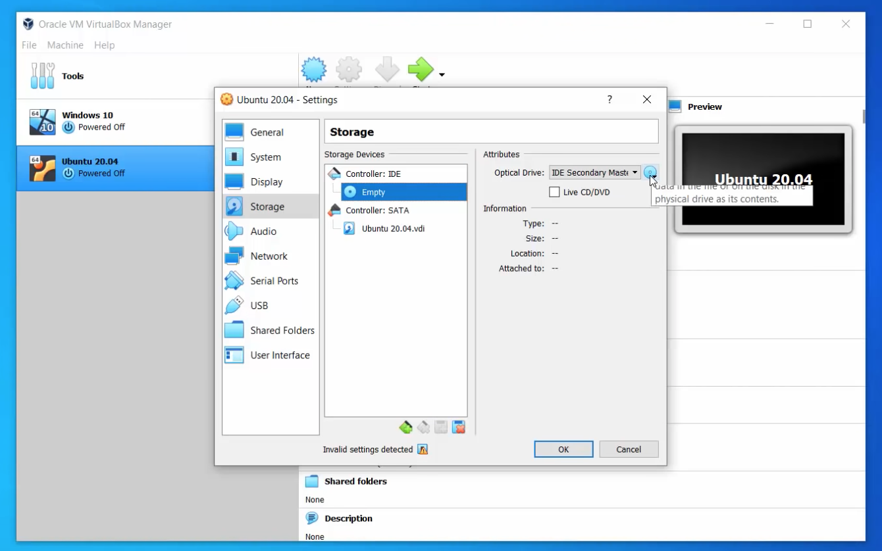

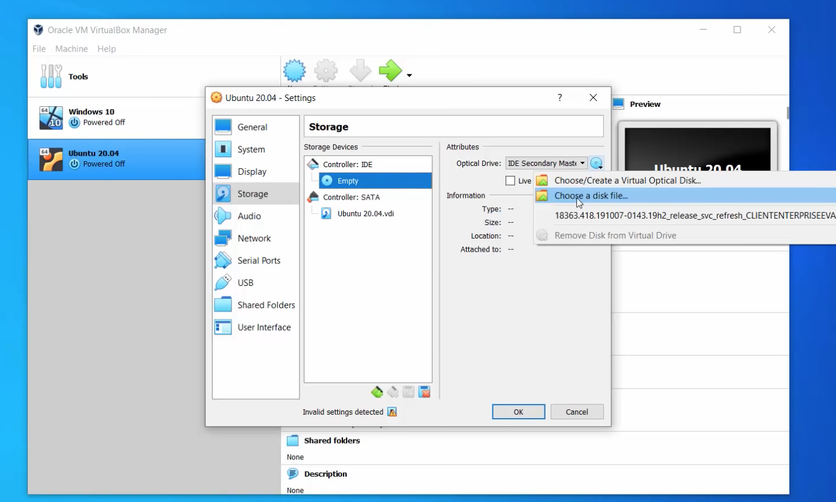

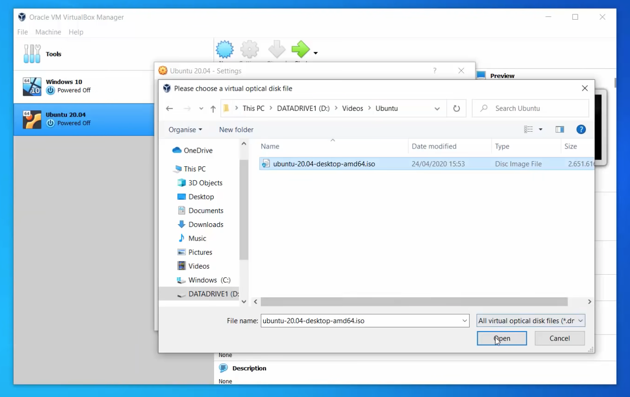

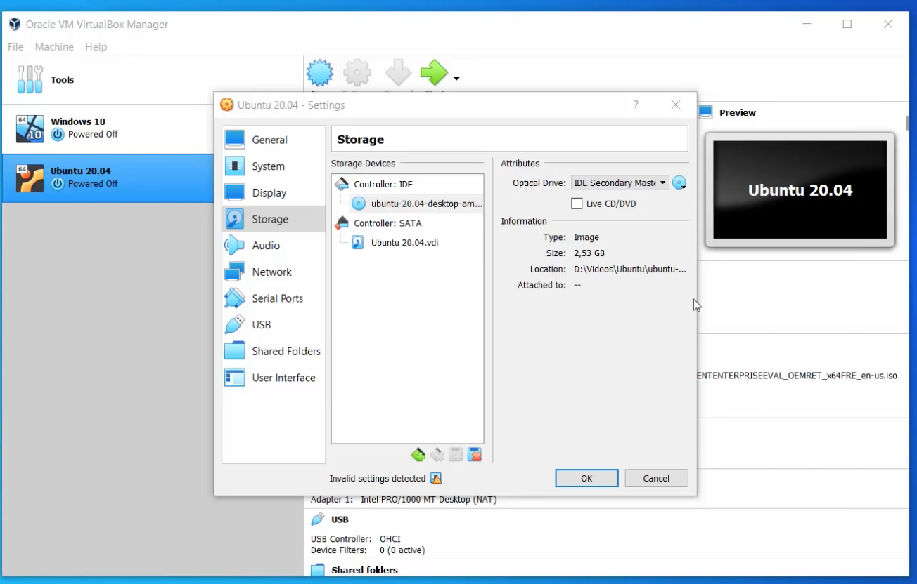

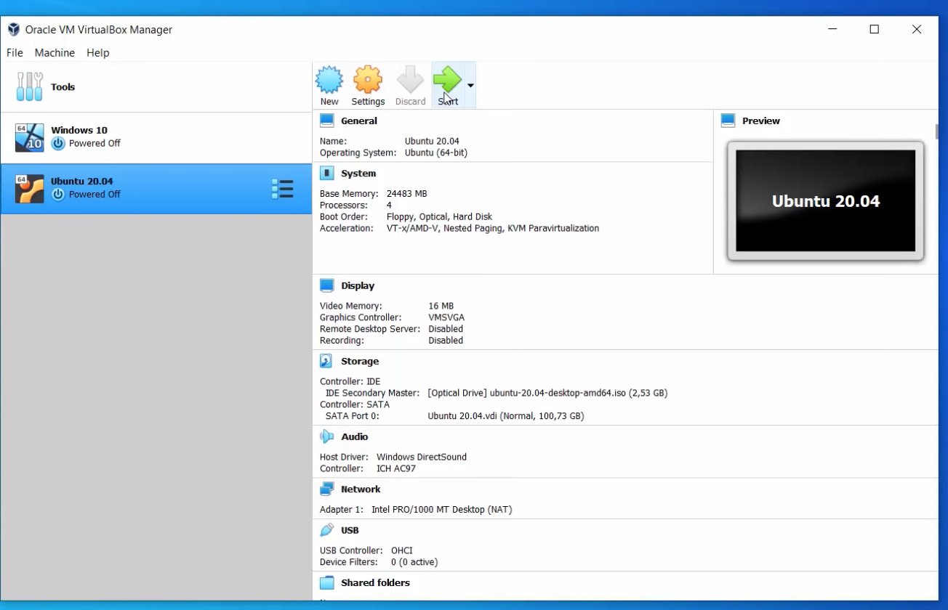

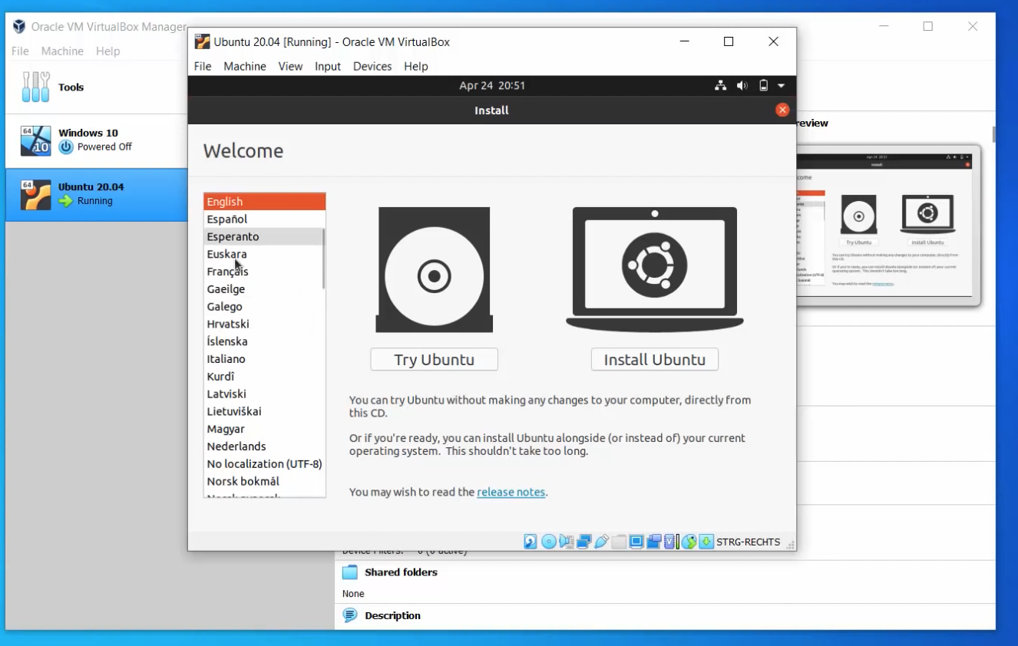

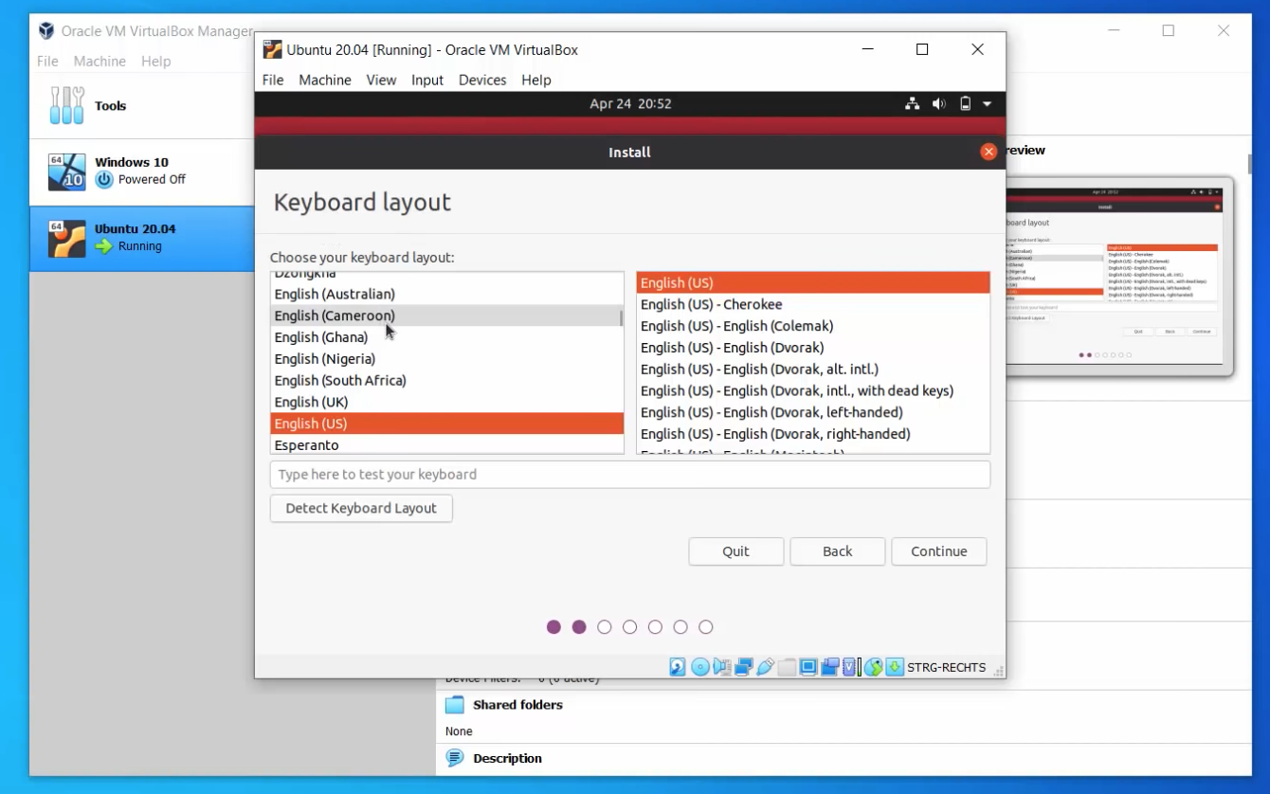

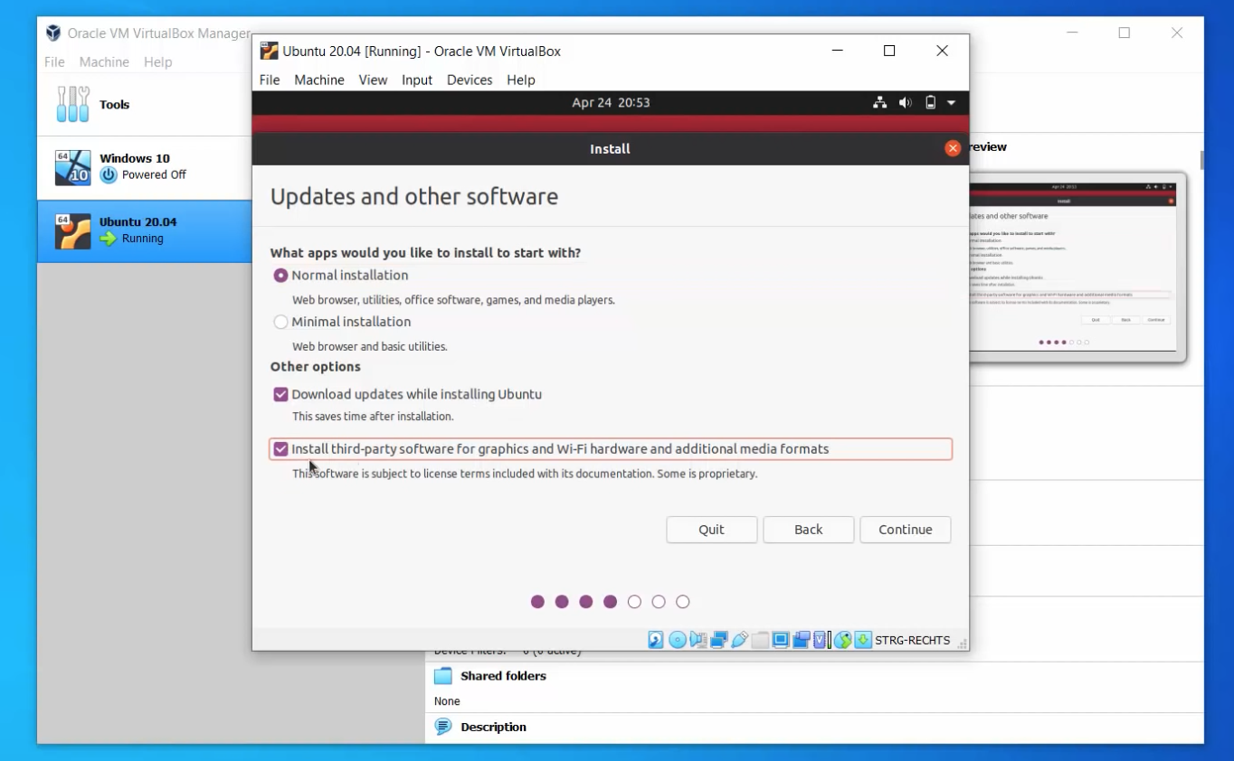

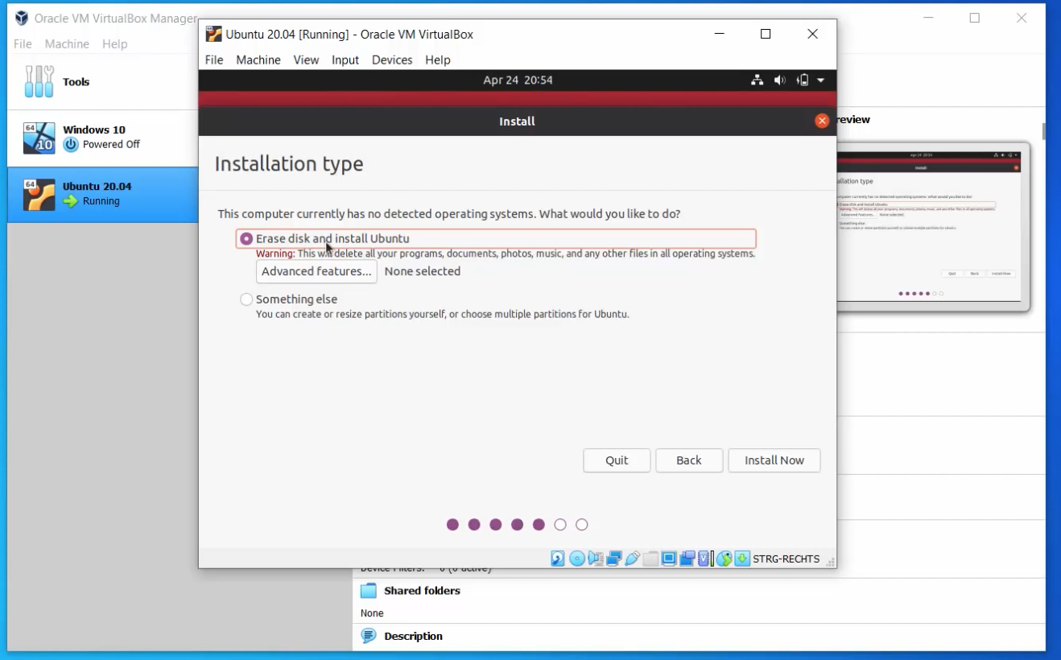

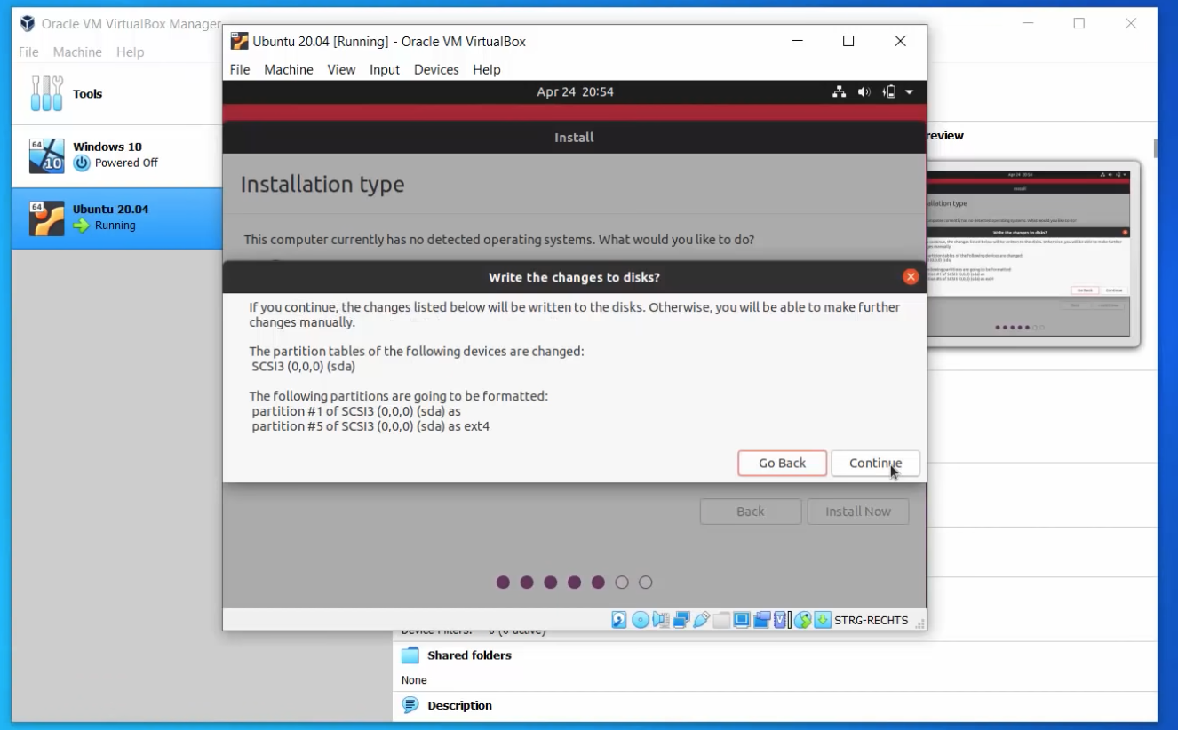

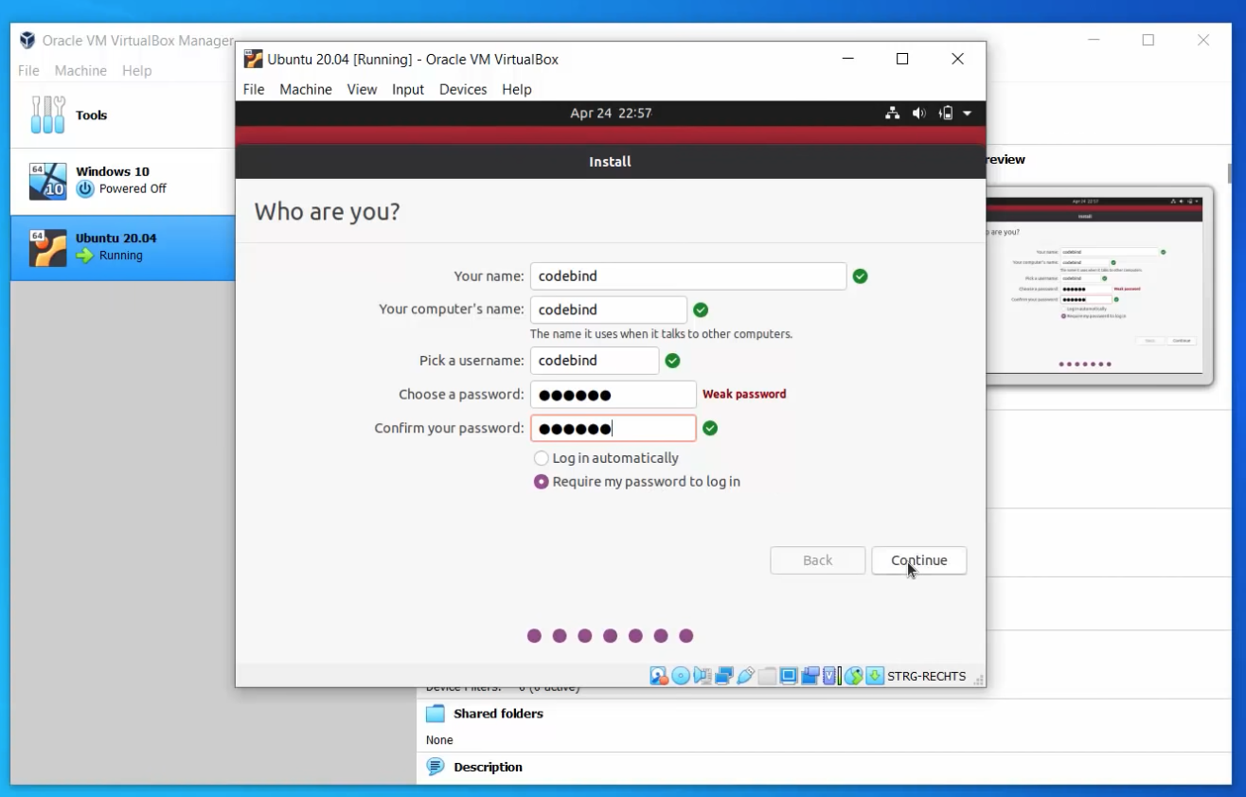

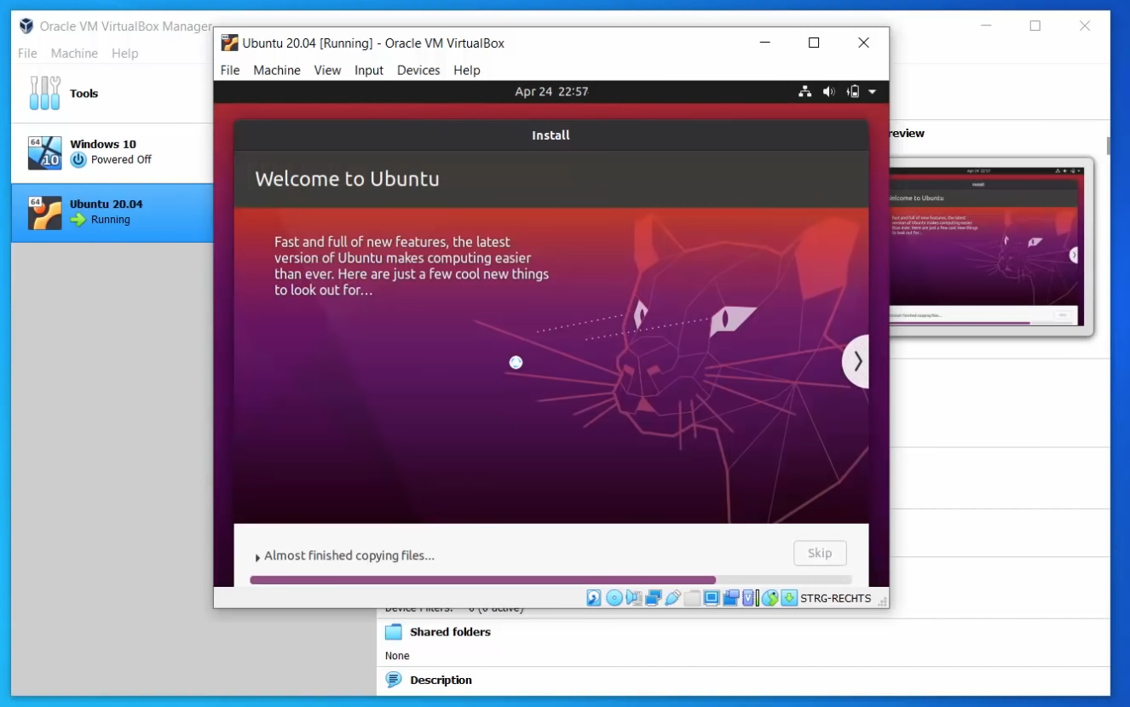

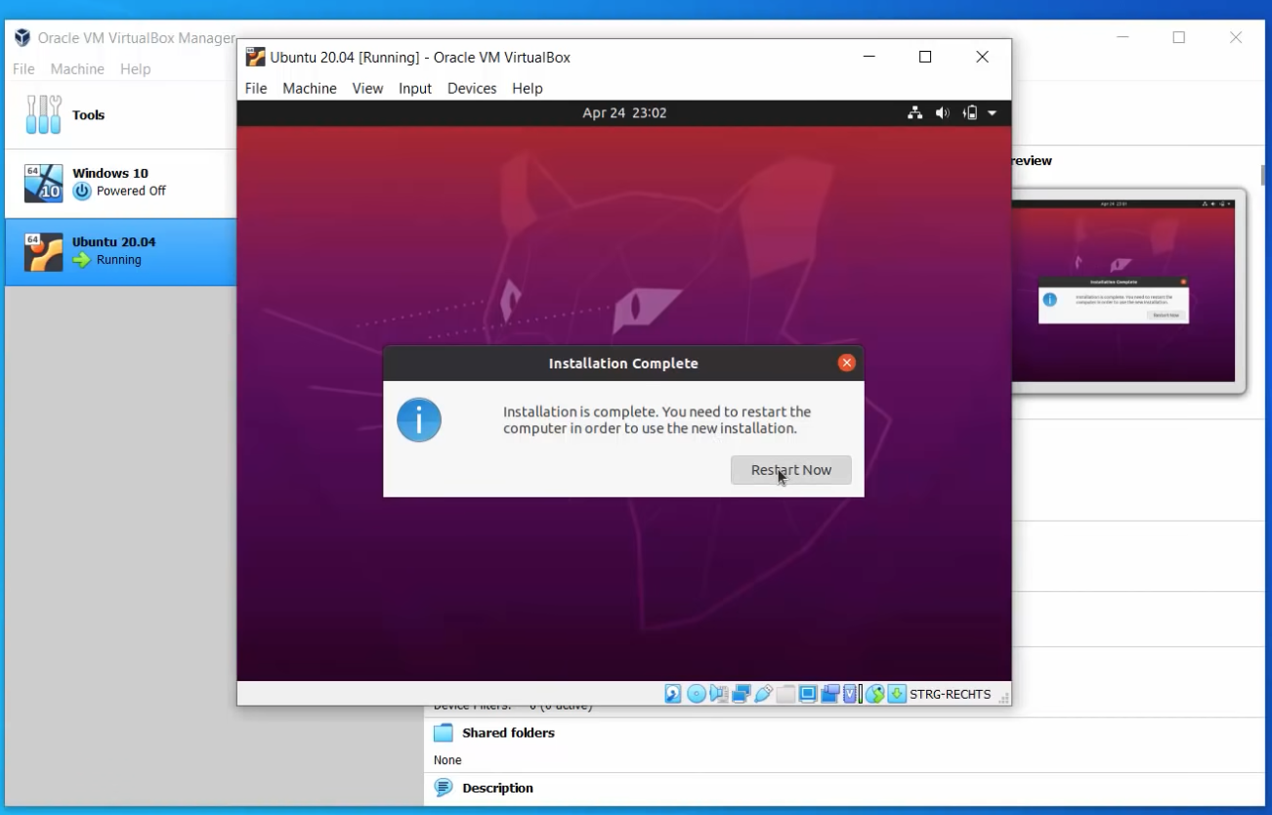

Virtual box installation steps are done

Step4: Open the virtual box in terminal

Installed Java, Git,Maven,Jenkins in the virtual box

Step5:sudo apt install java openjdk-8–jdk give this command to know whether java is installed or not java –version

sudo apt install git

to check whether git installed or not

git –version

sudo apt install maven

to check whether maven installed or not

mvn –version

Step6: Steps to install Jenkins

wget -q -O - https://pkg.jenkins.io/debian-stable/jenkins.io.key | sudo apt-key add –

sudo sh -c 'echo deb https://pkg.jenkins.io/debian-stable binary/ > /etc/apt/sources.list.d/jenkins.list'

sudo apt update

sudo apt-get install Jenkins

sudo systemctl status Jenkins

sudo systemctl start Jenkins

Jenkins dashboard will open in chrome or browser localhost:8080 give administrator

password by copying the path in terminal with sudo cat path like /var/lib/Jenkins/password/ etc…

Install suggested Plugins in Jenkins dashboard.

Performance plugin need to be installed and git ,gitlab,github.plugins to be installed

Step7:Steps to install apache-jmeter

We need to install in root dir

wget <http://www.gtlib.gatech.edu/pub/apache/jmeter/binaries/apache-jmeter-5.5.tgz>

tar -xvzf apache-jmeter-5.5.tgz

cd apache-jmeter-5.5/bin

sh jmeter.sh

systemctl status apache-jmeter-5.5

./apache-jmeter-5.5/bin/jmeter –version

After installing apache-jmeter we need to add one parameter in user-properties file in bin folder

jmeter.save.saveservice.output_format=xml

Jmx file we will get from the git source code (healthcheck.jmx) <https://gitlab.smartenspaces.com/saas-smartenspaces/jmeterLoadtest>

In Jenkins dashboard build environment in execute shell give this command

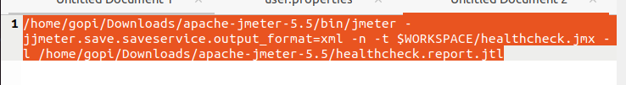

In post build actions give this path

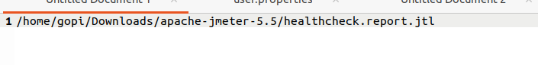

After giving this path perform build in the Jenkins dashboard .

Deployment will get the success will get the J meter report

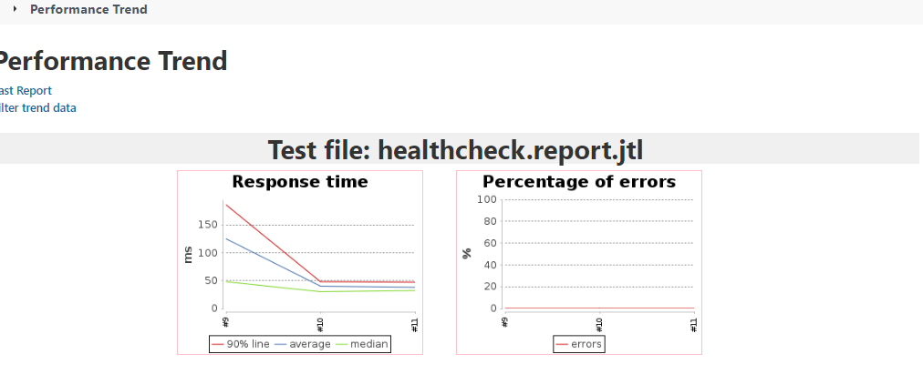

This is how the POC has been done for JMeter configuration with Jenkins

Tried same with our organization in Jenkins dashboard

Installed apache-jmeter in our Ubuntu 18.04 machine

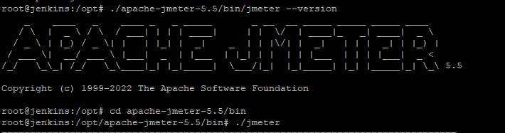

In apache-jmeter /bin in user-properties file add this command

jmeter.save.saveservice.output_format=xml

With the same steps stated above

Performance plugin need to be installed in Jenkins dashboard available plugins.

In Jenkins dashboard also execute shell given this command

/opt/apache-jmeter-5.5/bin/jmeter -jjmeter.save.saveservice.output_format=xml -n -t $WORKSPACE/healthcheck.jmx -l /opt/apache-jmeter-5.5/healthcheck.report.jtl

Source code path will be

/opt/apache-jmeter-5.5/healthcheck.report.jtl

Performed build with these inputs and got build success and got the jmeter output also